Online Credential Program  with  San Diego State  University  Through our grant, we are offering an online credential program with San Diego State University. This program is only available to current or incoming grant participants. This online credential program has been designed to accommodate our classified employees and their unique situation with their current employment. The online program offers a Multiple Subject Credential or a Bilingual Multiple Subject Credential through a two-semester timeframe. The next online cohort will begin Fall of 2019 and end Spring of 2020. Candidates interested in the program need to submit their application by March 1st, 2019. The total cost for the program is approximately $8,500; the cost does not include costs for prerequisite courses.  Once a student expresses interest in the online program, a Grant Educational Advisor will be in communication with the student. The advisor will help students through the application process and provide additional information and/or clarifications about the program. | 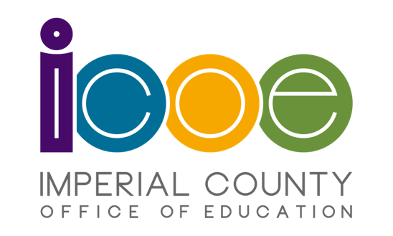

If you are interested, please complete the following survey: https://goo.gl/forms/QfPBXderXROme0F13

A Grant Educational Advisor will be reaching out to you after you complete the survey, but it is highly recommended that you begin your application. Below you will find the application process and general information about the program that may assist you during your application process.

Application Process
Steps to apply for the SDSU Online Credential Program
-Download this PDF and click on the hyperlinks in blue.

Credential Program Cost
Approximately $8,500 (Not including prerequisites)

CBEST & CSET
You will need to have your CBEST Passed and at least 1 subtest from the CSET Multiple Subjects exam by May 4th, 2019. If you need support with these exams, please reach out to your advisors.
Register here for exams through the CTC website

Checklist & Prerequisite Courses
Use this document to guide you with application requirements: Checklist & Prerequisites

Financial Aid & Grants
It is highly recommended you apply for Financial Aid as an extension of your education.
Click here to begin your application: FAFSA

We also recommend you apply for the TEACH Grant.
Click here to read about the grant and to apply: TEACH Grant

Online Informational Meeting Session via Zoom
We will be hosting an online Zoom meeting to answer any questions or concerns. The meeting will take place mid-January. To receive the meeting link, you must have completed the survey mentioned above.

If you have any questions, please email dle@sdsu.edu and CC fes@bcoe.org.

